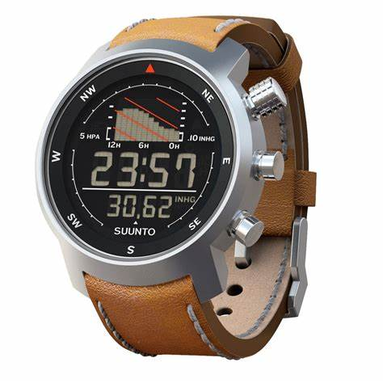Description: Suunto is a Finnish brand known for its high-quality sports and adventure watches, designed for athletes, outdoor enthusiasts, and professionals. Suunto watches are equipped with **advanced GPS tracking, heart rate monitoring, barometer, altimeter, and compass**, making them ideal for hiking, running, cycling, and diving. They are built to withstand extreme conditions with **rugged, water-resistant designs** and long battery life. Many Suunto models also feature **smartwatch capabilities**, including smartphone notifications and fitness tracking. With a focus on durability, precision, and innovation, Suunto watches are a top choice for those who demand reliable performance in both sports and outdoor adventures.